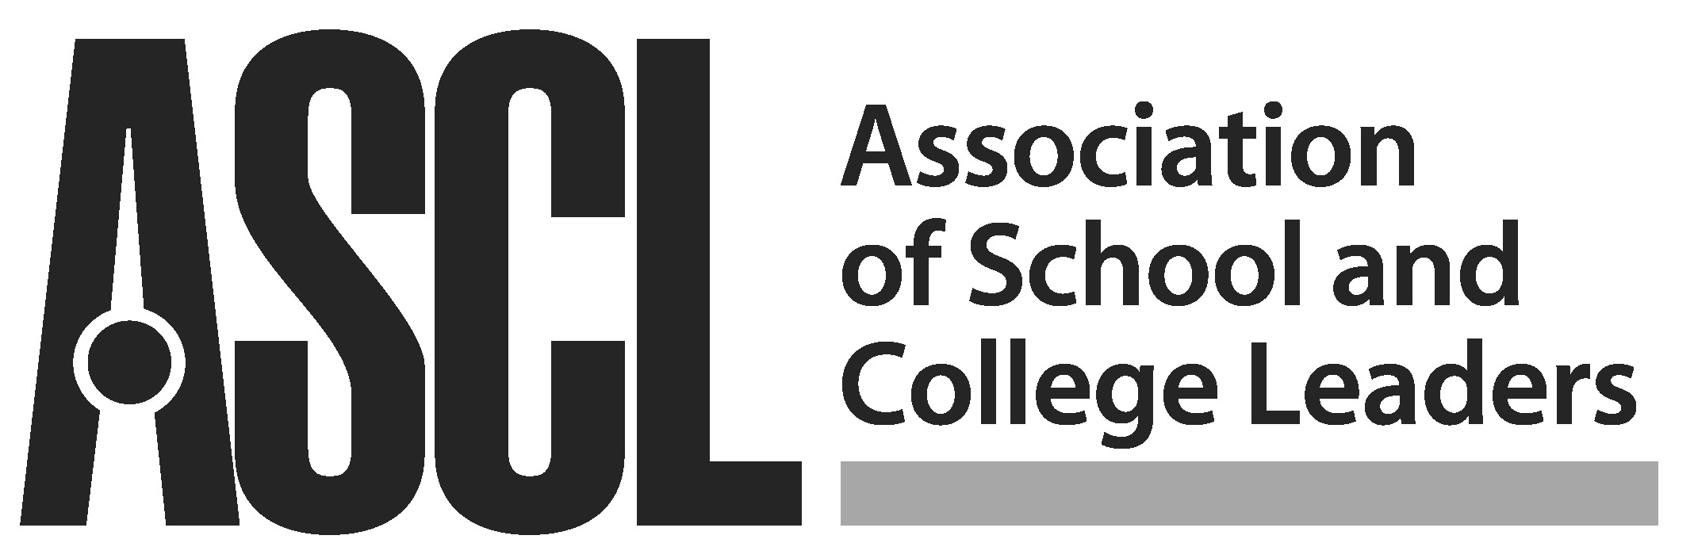

Election of National President 2020 - 2021

Nominations are invited for the post of ASCL National President 2020 - 2021. Members are informed that David Waugh, the current Vice President of the Association, has been nominated by ASCL Council.

Candidate nominated for President 2020 - 2021:

Name: ....................................................................................................Post held in school: ...........................................................................................

School/College: .................................................................................................................................................................................................................

................................................................................................................Email: ................................................................................................................

Nominated by: Supported by:
Name School 1 Name School
2 Name School
3 Name School
Seconded by: 4 Name School
Name School 5 Name School
Please return to Denise Hodgson, Executive Assistant to Presidential Trio and General Secretary, ASCL, 130 Regent Road, Leicester, LE1 7PG or email to denise.hodgson@ascl.org.uk by 12pm Tuesday 17 December 2019.

Please note:
Any full member of ASCL may submit a nomination. The agreement of the person nominated must be secured before she or he is proposed and seconded. A further five supporters are required to be named on the nomination form. Proposers, seconders and supporters must be ASCL members. In the event of two or more nominations for one post, nominees will be sent a detailed nomination form. Each candidate will be given the opportunity to include an election address. The address will be printed unedited on the voting papers which will be distributed by the Electoral Reform Services. The ERS will act as independent scrutineers throughout the election.

We would particularly welcome nominations from people from groups traditionally under-represented on ASCL’s Presidential Trio, including women, representatives of black, Asian and minority ethic (BAME) communities, assistant and deputy heads, and leaders based in early years, primary or FE settings.

